How to add a User Override for Extended Time or Makeup Exams
- Go into the exam/quiz edit settings by clicking on the exam, or by clicking on edit settings.
- From the exam Administration panel choose User Overrides.
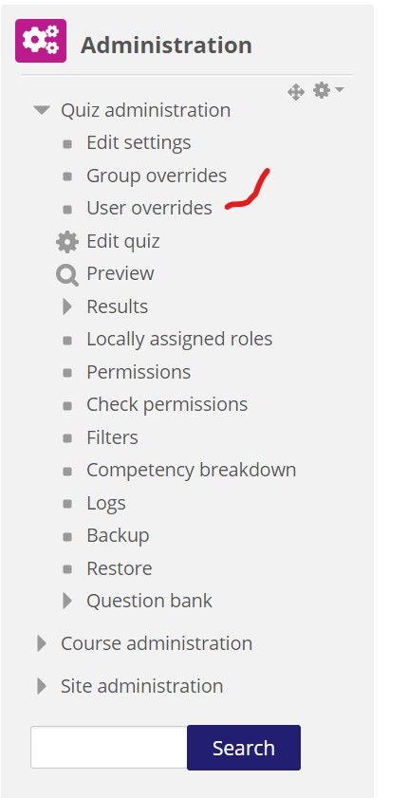

- Click on Add User Override.
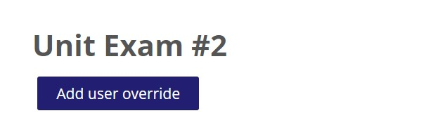

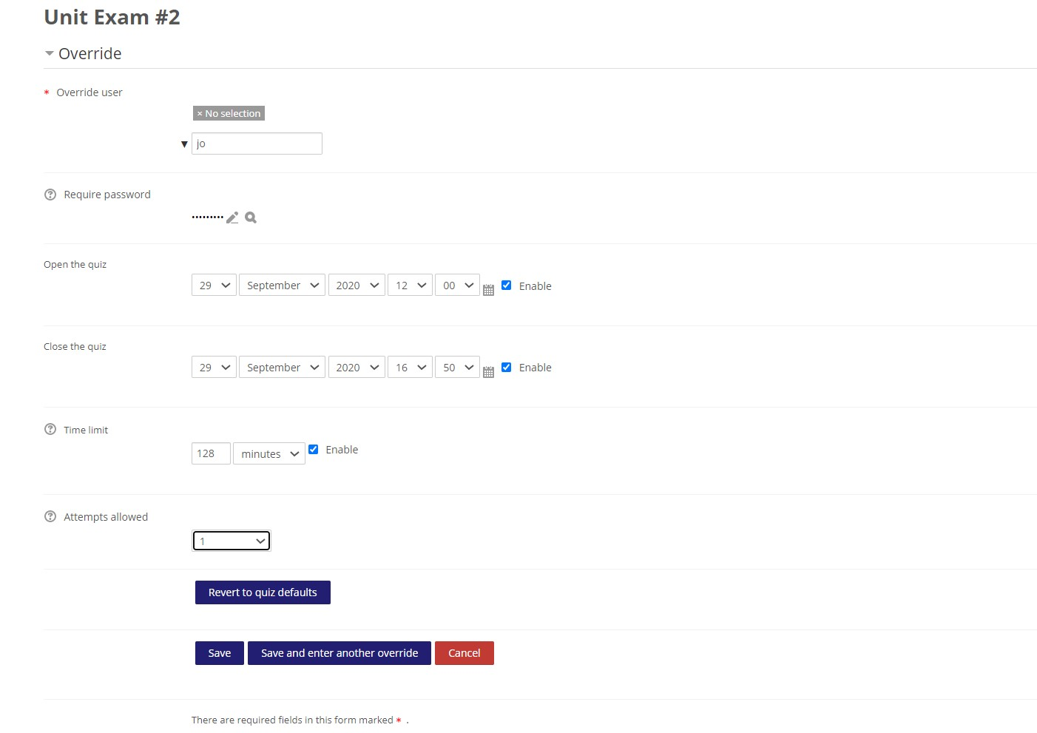
- Enter User, Quiz Open, Quiz close time. The password will be the same as the one set in edit settings under Extra restrictions. Choose save and enter another over.

