Phillips Beth Israel School of Nursing
Moodle Online Grade Book

- How to add/update Student ID Number on Moodle:

- Log in to Moodle.
- On the top of the screen, click on student’s name.
- Click on “Edit Profile”.
- Scroll down to Optional and click “Show Advanced”.
- Under ID Number, type in the last 4 digits of SSN (Same 4 digits used for the school exams).
- Click on “Update Profile”.

- How to view list of students and student ID numbers

- Log in to Moodle and choose course.
- Under Administration (on the left), click on “Grades”.
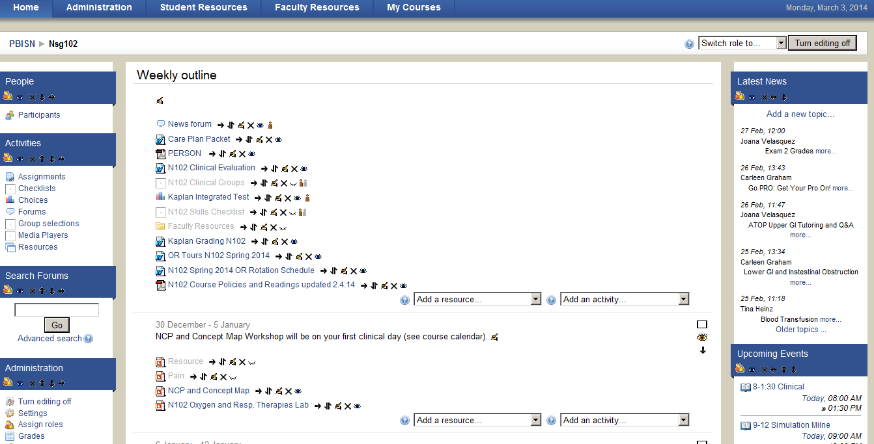

- Click on “Choose an action”, choose “Export Excel spreadsheet”.

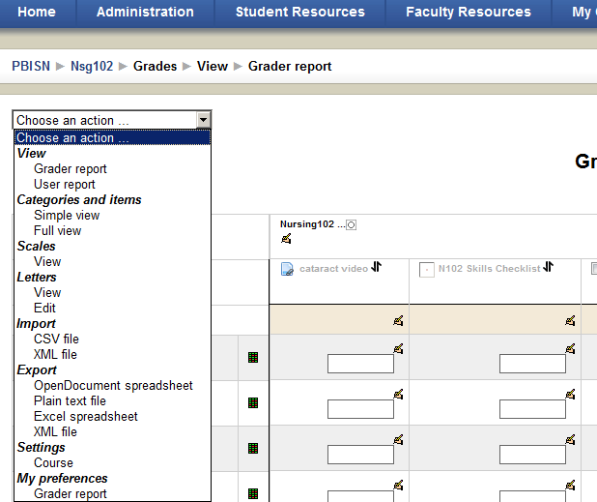

- Click “Select all/none”.

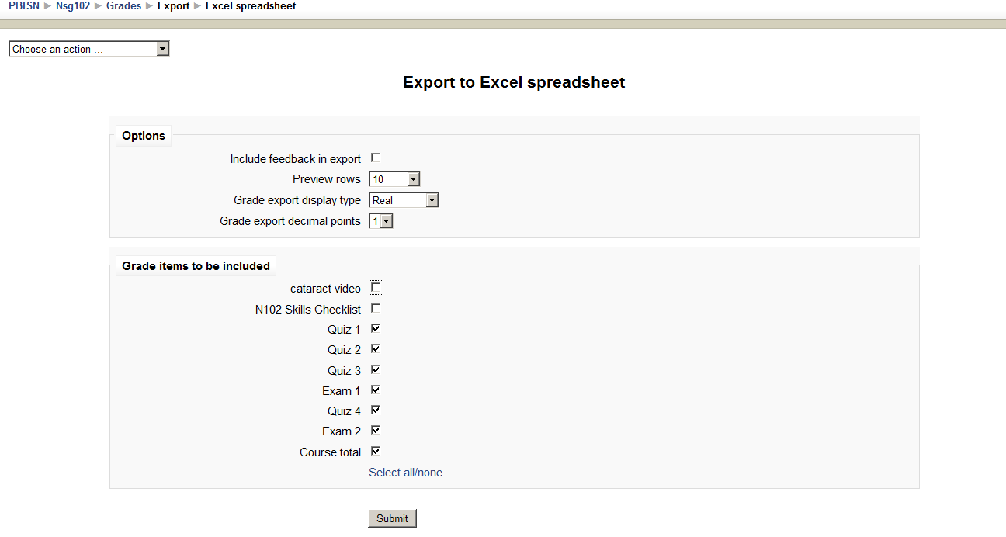

- Click “Submit”.

- Click “Download”.

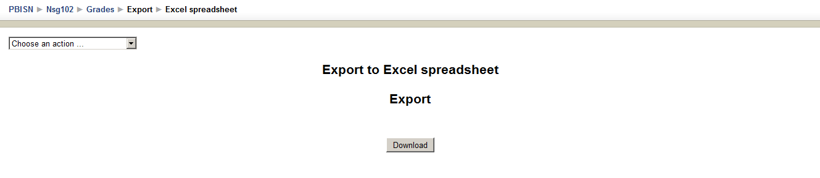
- Choose to either Save or Print file.

- Course Grades Settings

- Go to the course homepage.
- On the left, under Administration, click “Grades”.

- On the left, click on the arrow down button next to Choose an action.

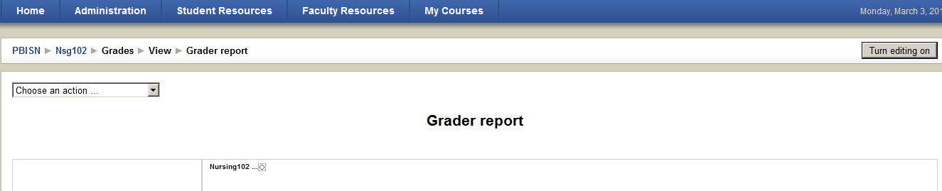

- Click on “Settings, Course”.

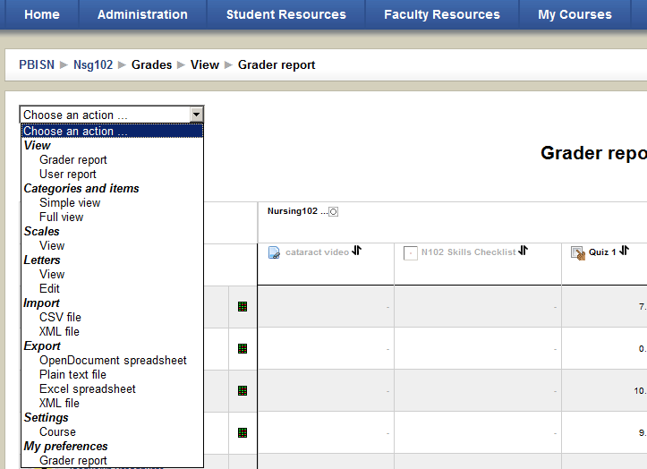

- Default Screen
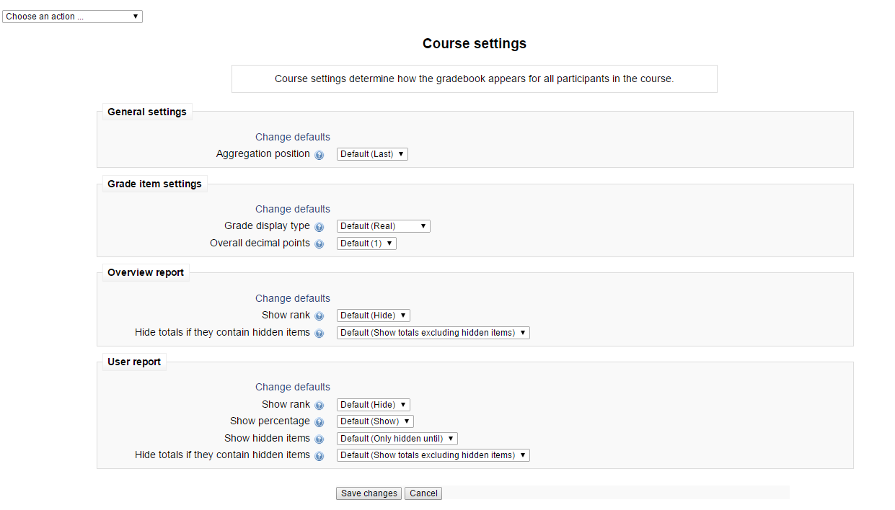

- Creating a grade landscape:

- Log in to Moodle.
- Choose the course (i.e., N102).

- Under Administration (on the left), click on “Grades”.

- On the left, click on the arrow down button next to “Choose an action”.

- Click on “Full view” under Categories and items.

- Under Aggregation, choose “Weighted mean of grades”

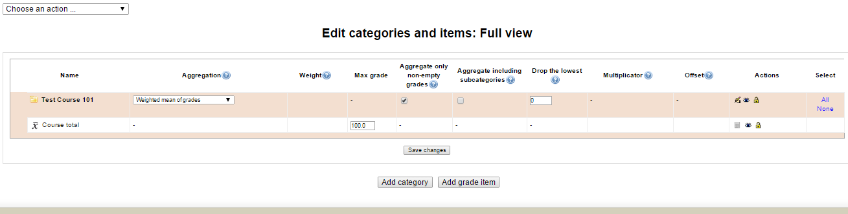

- Click on “Add grade item”.

- Add grade item name and maximum score.

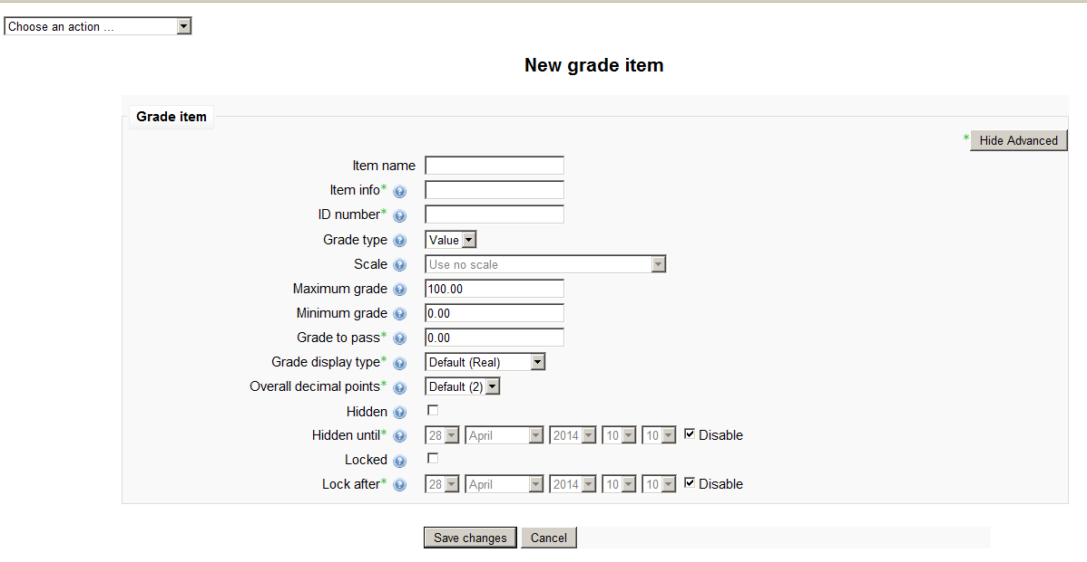

- Click “Save changes”.
- Enter grade item weight and click on “Save changes”.

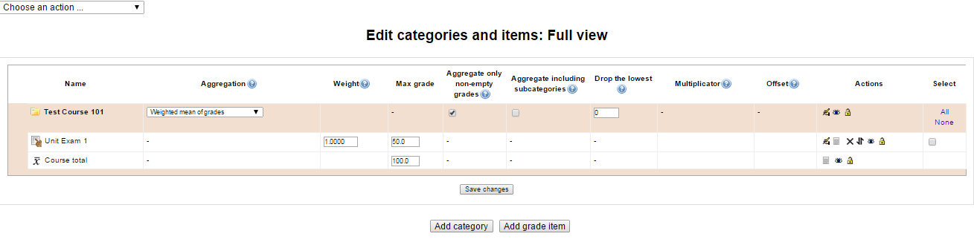
- To delete, click the “X” icon for the grade item to be deleted.

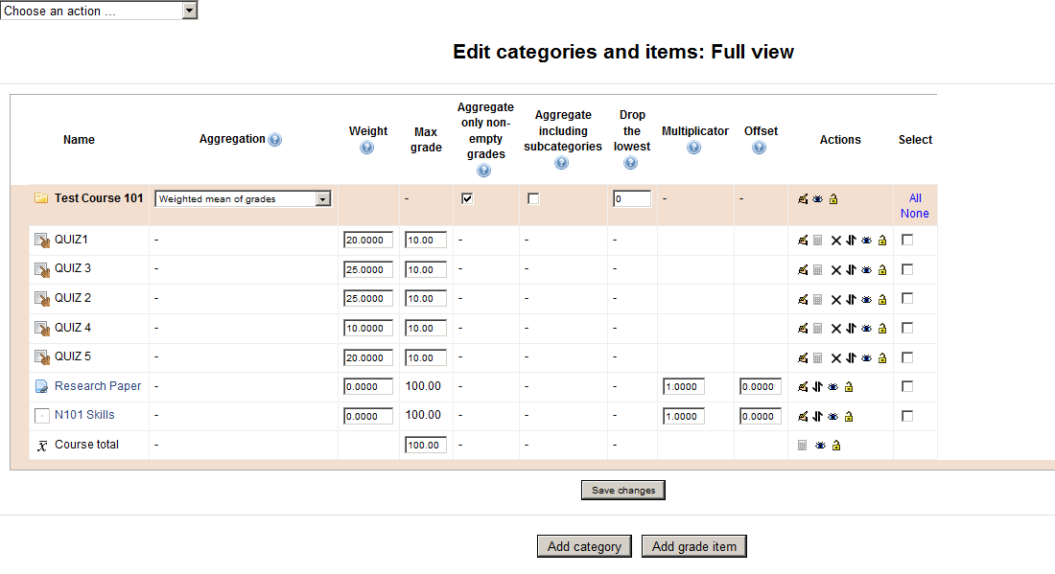
Note: You can change the weight and maximum grade on this screen. Make sure you click Save changes at the bottom of the screen when finished.

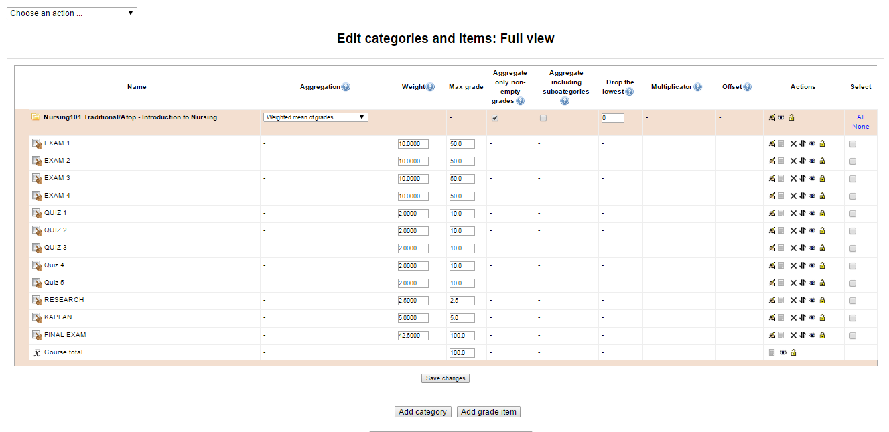
- How to manually enter grades on Moodle

- Go to the course homepage.
- Under Administration (on the left), click on “Grades”.

- The Grader Report screen will open. On the right, click on “Turn editing on”.

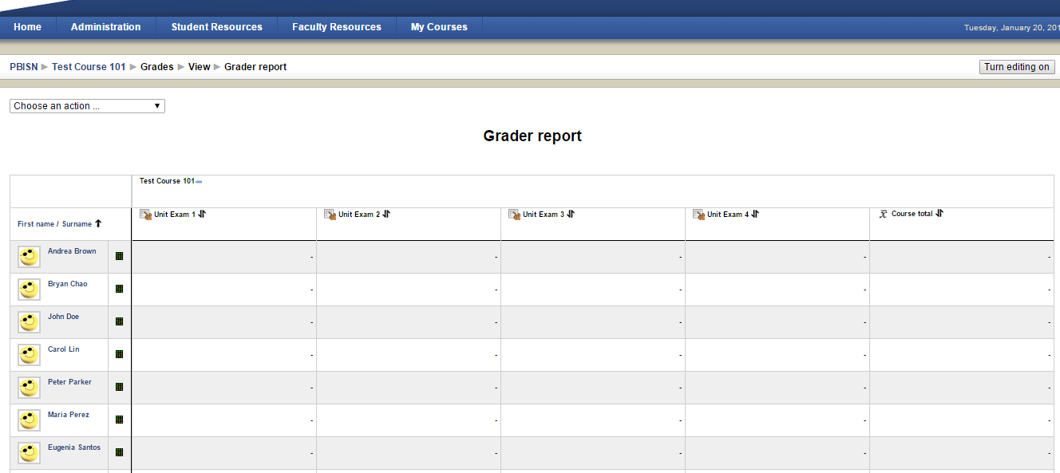
- The screen for grade editing will open. Click on the field that you need to complete and click “Update” when finished.
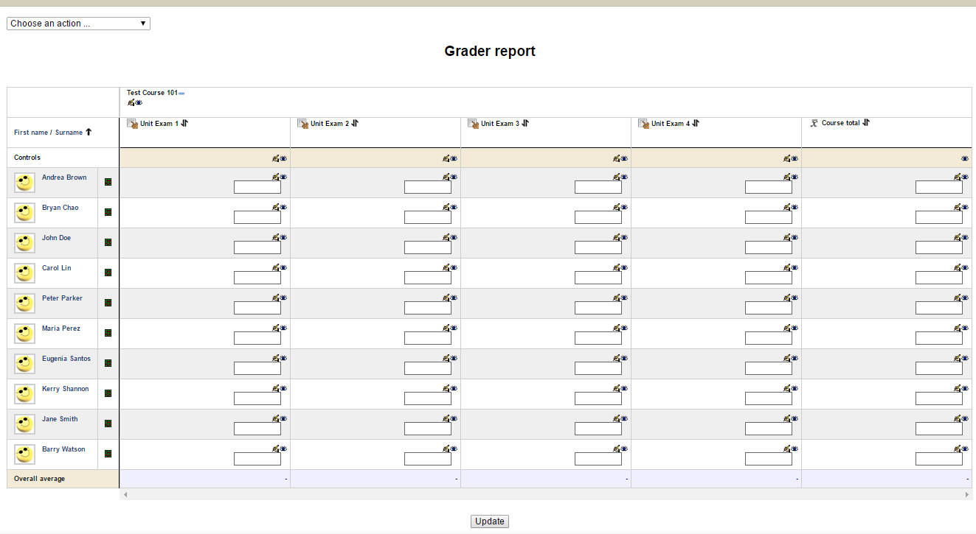

- How to convert Excel file to CSV file

- Open Excel file (i.e. student statistics report).
- Copy Student and Total column to a new document.
- Rename Student column to Student ID.
- Rename Total to Grade item name (i.e. Exam 1).
- Click on File then Save as.

- Name the file (i.e. Spr14 N102 Trad Exam1).

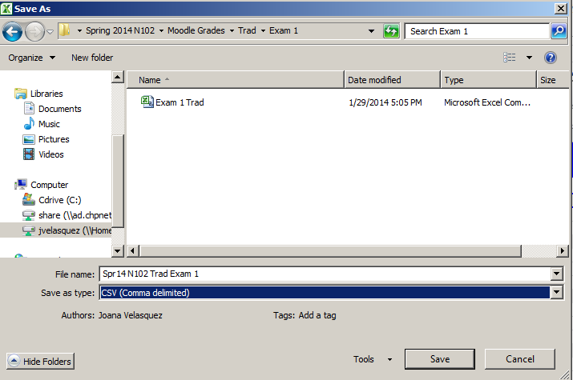

- On Save as type, chose CSV (Comma delimited).
- Click Save.

- How to upload grades on Moodle via CSV file

- Log in to Moodle and choose course.
- On the left, click on “Grades”
- Click on “Choose an action”, choose “Import CSV file”.

- Click on “Browse” and double click on file to be uploaded.

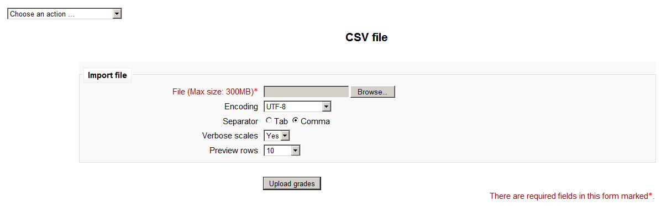

- Click “Upload grades”.
- The screen below will open.

Identify user by
Map from- Student ID
Map to- change to “useridnumber”

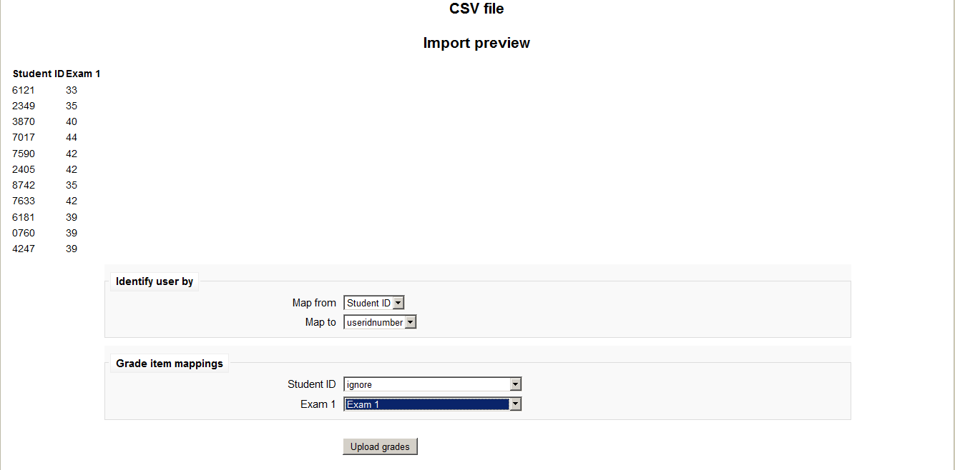
- Grade item mappings
Student ID- ignore
Item name (i.e. Exam 1) - grade item name (i.e. Exam 1)
- Click “Upload grades”. (Wait for confirmation- “Grade Import Success”)
- Click “Continue”.

- How to export grades as an Excel file

- Log in to Moodle and choose course.
- On the left, click on “Grades”.
- Click on “Choose an action”, choose “Export Excel spreadsheet”.

- Choose grade items to be exported.

- Click “Submit”.

- Click “Download”.

- Choose to either Open or Save file.

