Turnitin
Accessing and Grading Submitted Papers
- Log in to Moodle and access the course homepage.
- Locate the Turnitin Assignment.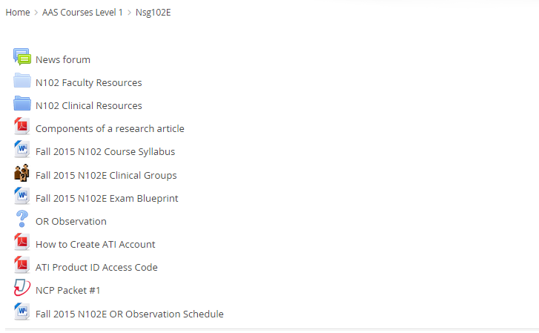
- Click on the link. The screen below will open.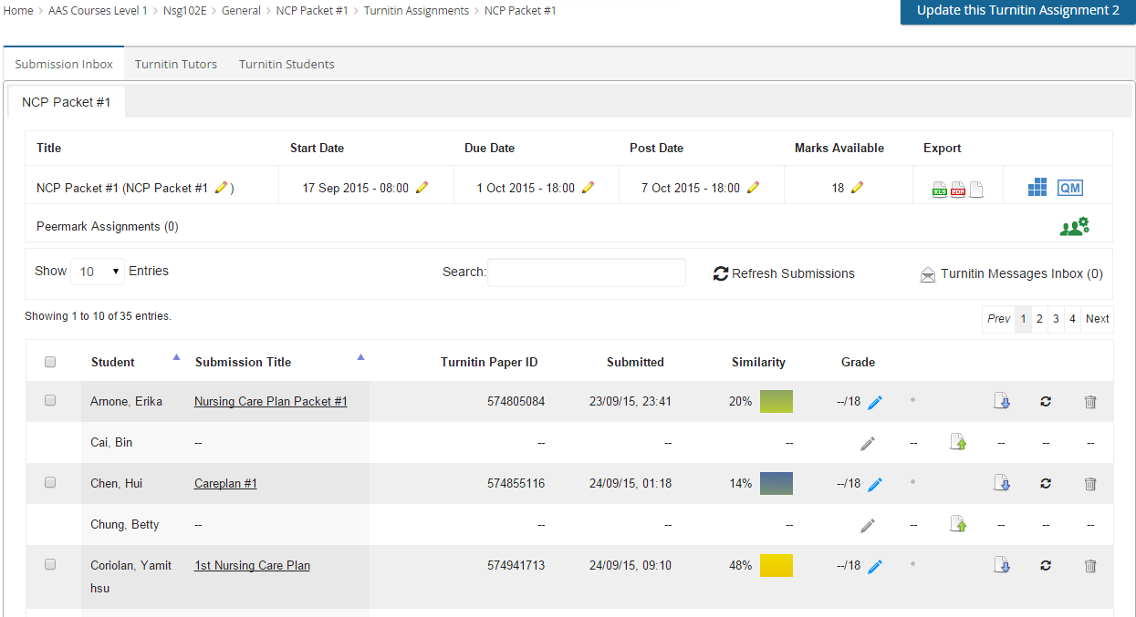
- Locate your student’s submission and click on the Submission Title to open the file on the document viewer. (Note: You may also opt to download the submitted document by clicking on the “download” icon.
- Once the document viewer is open, click on originality 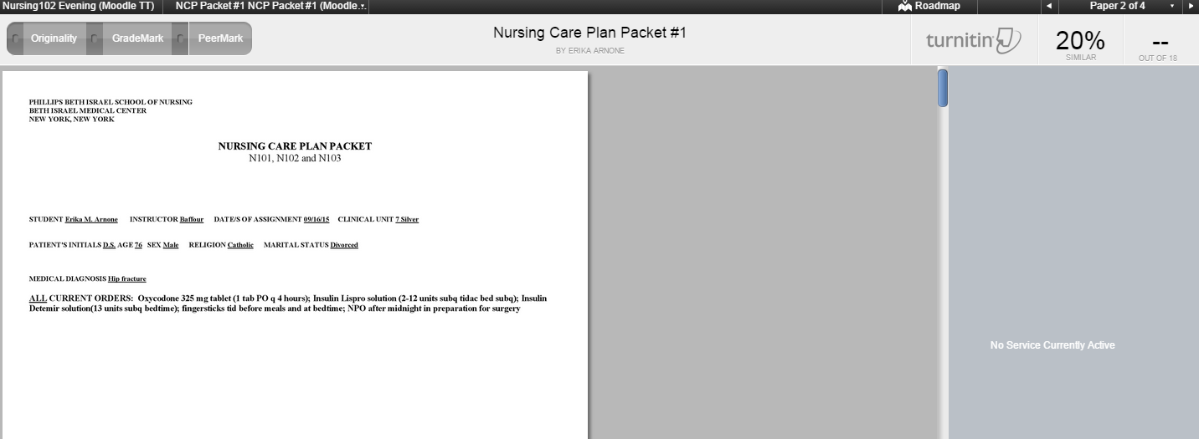
This will highlight parts of the submission that was compared with other submissions on the internet and repository.
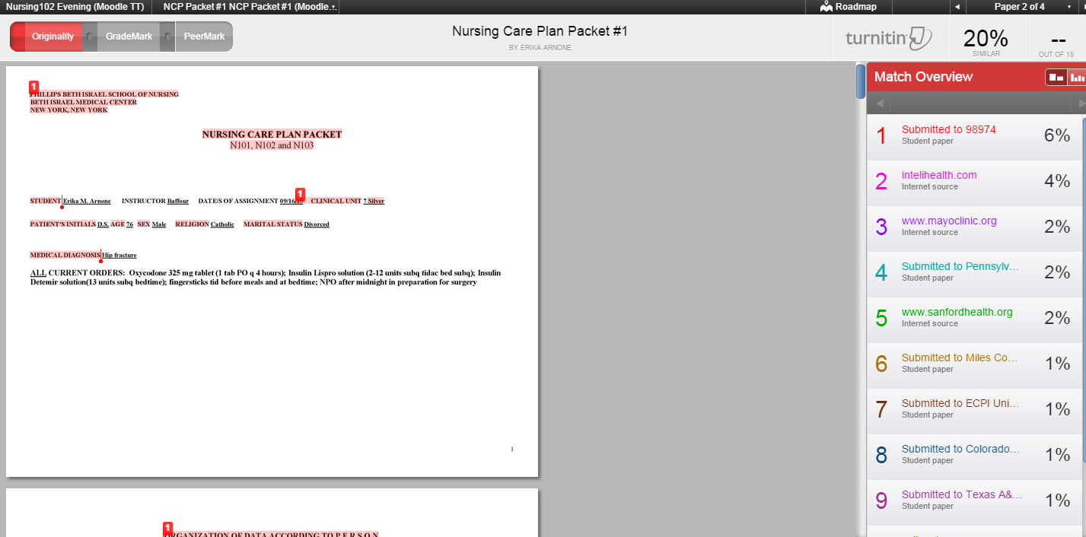
- Clicking on the Grademark on the tab will allow you to add comments. (Always save your comments.)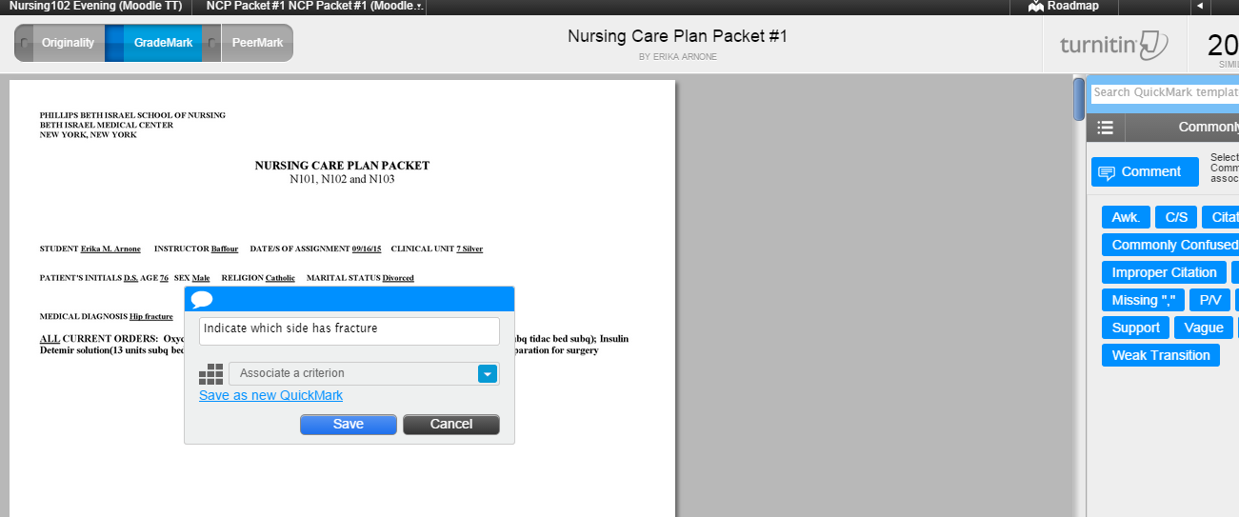
- Once all comments are in, click on the bottom right corner to access the rubric. 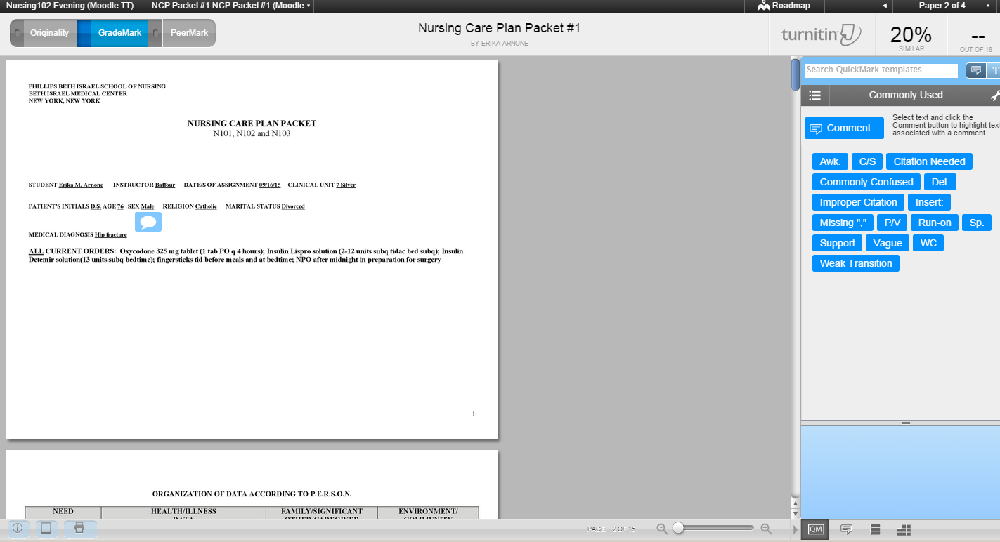
- Click on the appropriate grade for each criterion. (Hover your mouse pointer on the grade to view the description for that grade.) 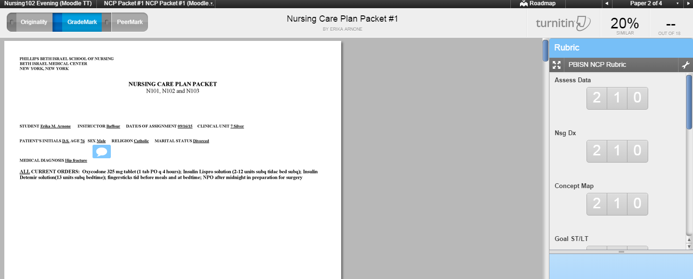
- Click “Apply rubric percentage to grade”. Notice that the grade will appear on top.
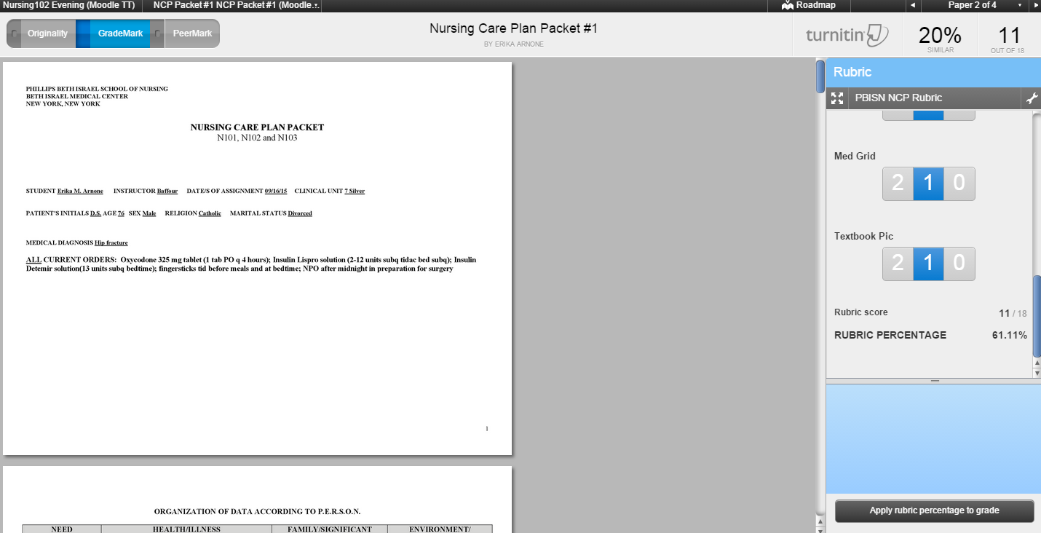

- Once completed, you may exit the document finder.
- When you go back to the assignment link, you will see that the grade will be posted. 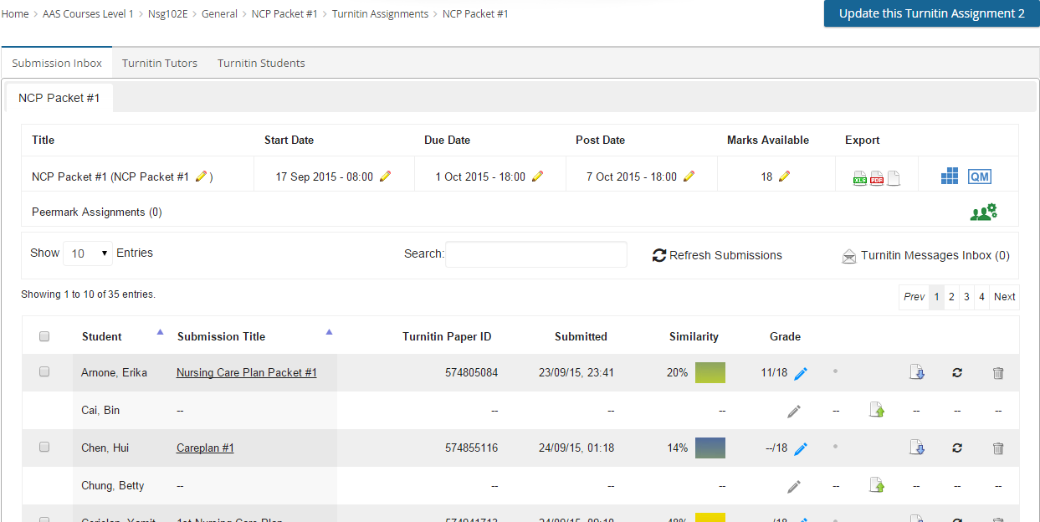
- If necessary, you may click on the blue pencil to re-open the document viewer and edit your comments and grades.

